Makerspace Checkout Setup
I created small cards to make checking out makerspace items easier to do. The idea was to have a small appealing card that shows what the kit is and fits under the fixed checkout scanner we use.
I created a template for a full sheet of card stock that allows space to make four cards. The barcode that I used for the item is at the top and you will need to use a barcode font to make it work. That will be enclosed with the package I am creating. Under the barcode I put the title of the kit and a picture of the kit under the title.
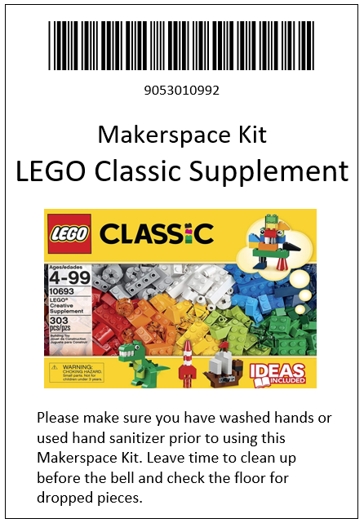
Since many of the kids using makerspace stuff are come from quickly eating lunch to the media center, I put information at the bottom that lets them know that they need to either wash their hands or use hand sanitizer prior checking out a kit. I also include a little more information that I want them to know and I make them read it before I check it out. Here is a sample.
I print out four cards at a time on white cardstock and then I use my pouch laminator with a 5 mil to seal them to make them last. Below is a link to the place I get the laminating supplies. It is a Utah company and I found that their prices are better than anywhere else. I also use their 8½ by 11 sized pouches to laminate important pages that I use in the library. The are sturdier and I think they look better than the thin roller laminators.

Laminating Supplies - http://www.officezone.com/pchstand.htm

